- Live Report Document (with edit history): [Insert Shared Google Doc / Word Online Link Here]

As I make here, you must upload this file on google drive and then you can take the link as I make here:
https://docs.google.com/spreadsheets/d/18KdQoWUC12fJylStiYftw4uJ6MACaLRi/edit?usp=sharing&ouid=114132335526923906510&rtpof=true&sd=true

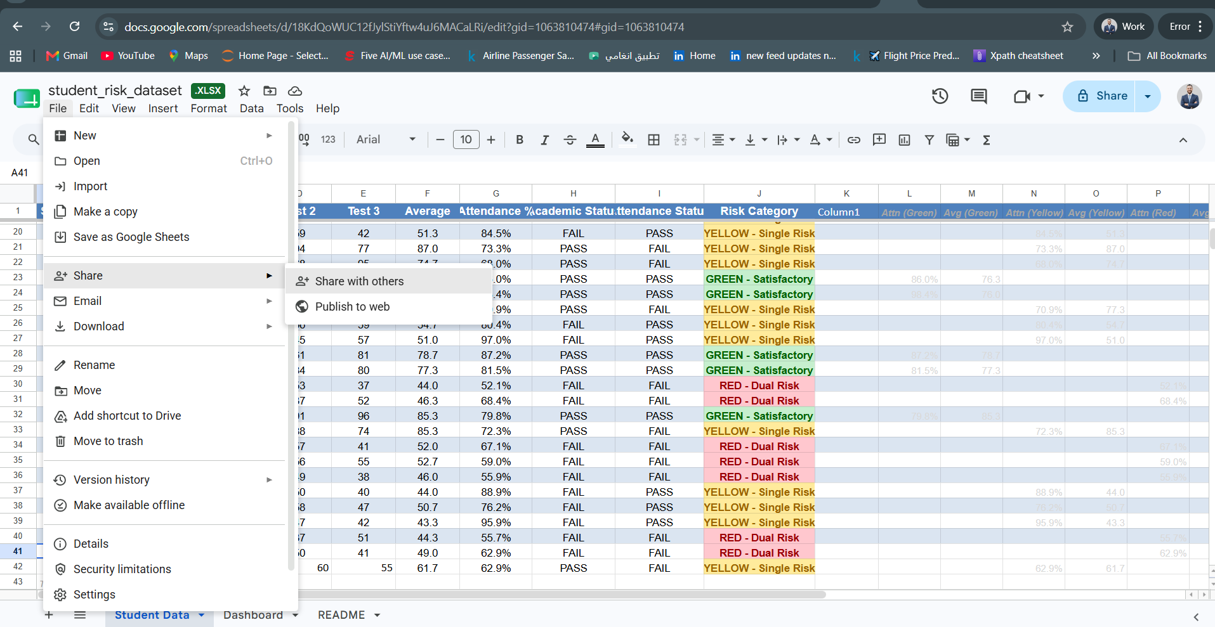
You can share this link to anyone and make an update on the work.
Also you can get all version history from here when someone update on it:

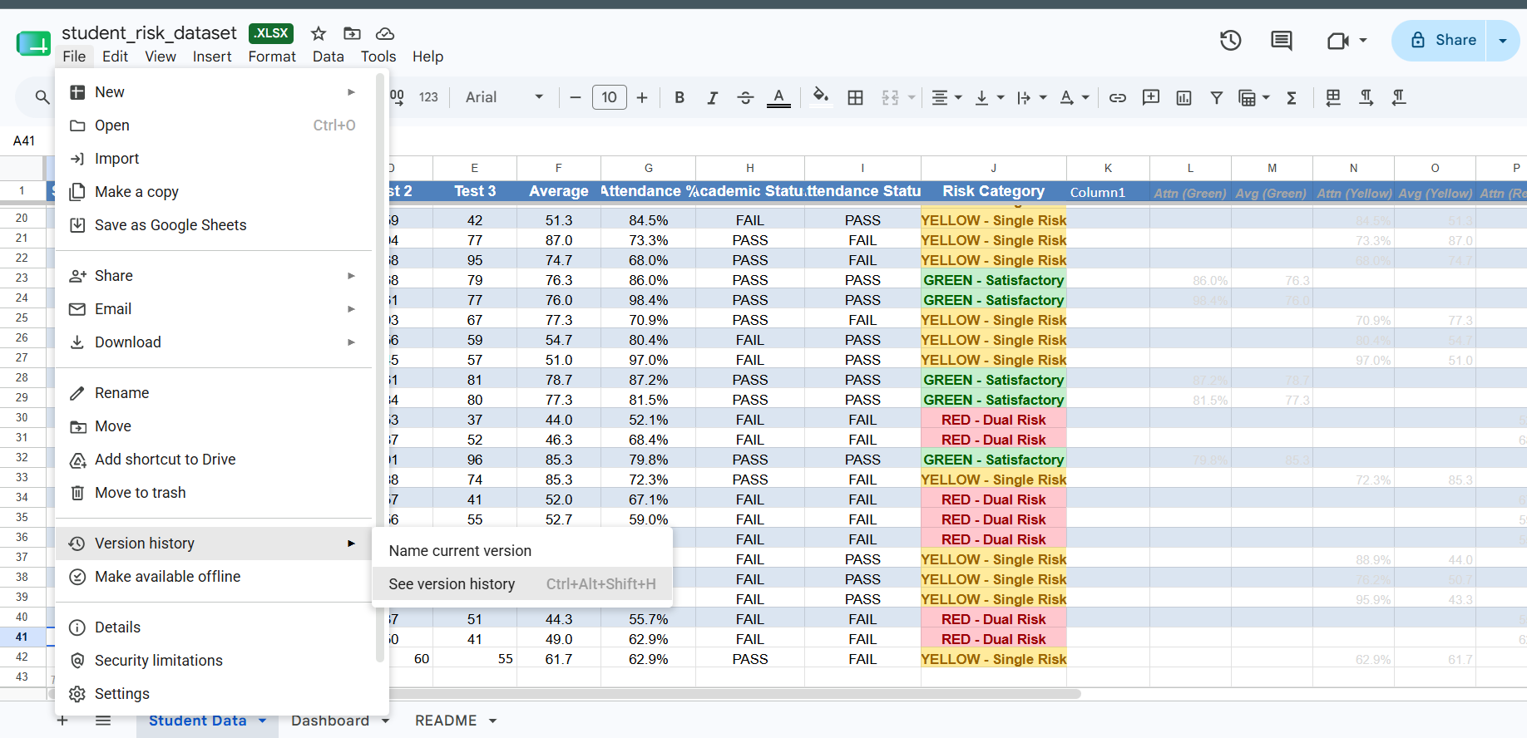

- Data Workspace Repository (with progress history): [Insert Shared Folder / Repository Link Here]
to make this step you must make an account on github and then, you can upload your project on it as I shown here:
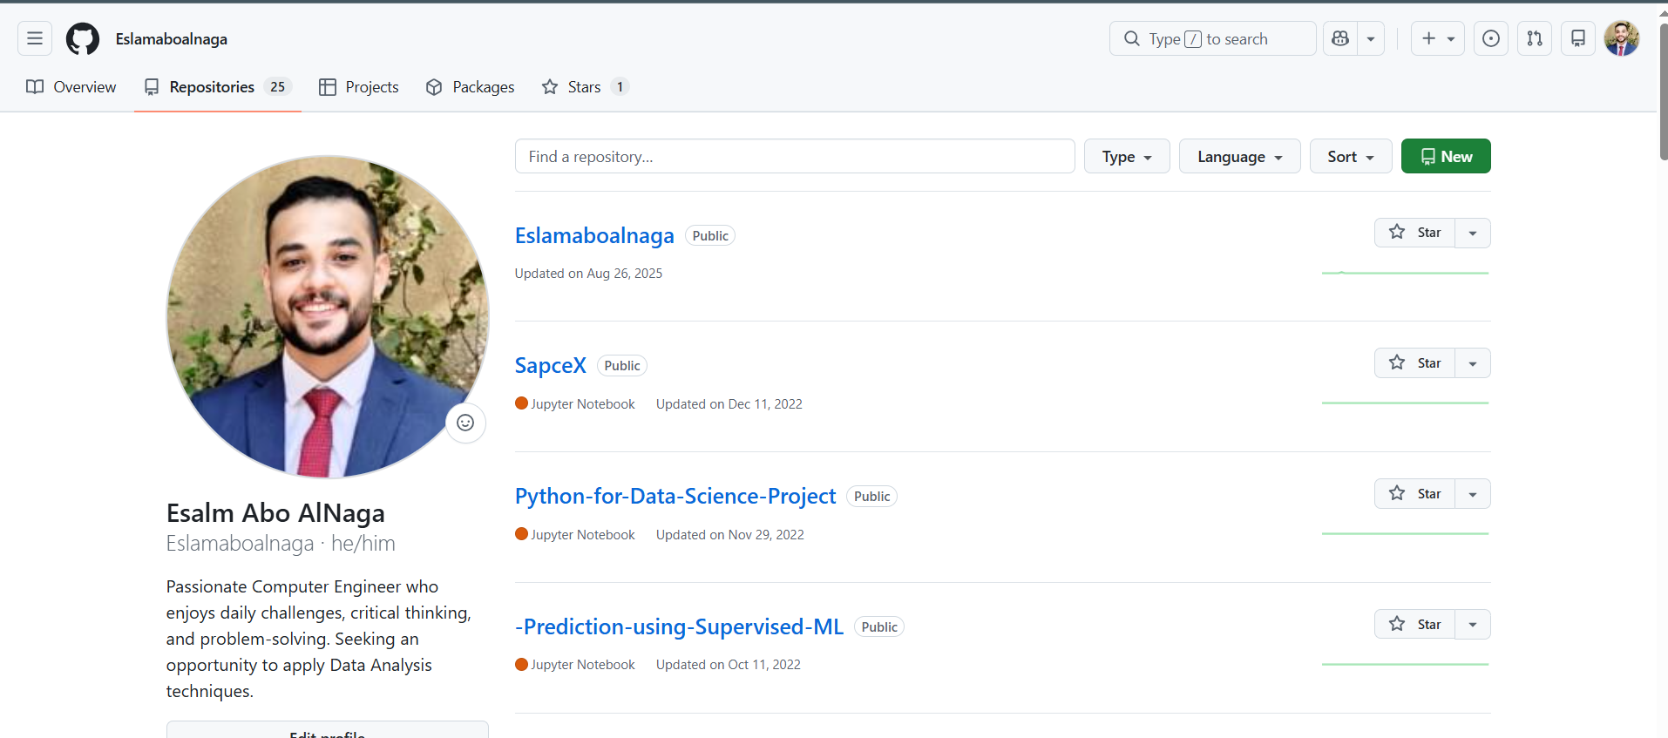
From repositories here you can make a new one for you
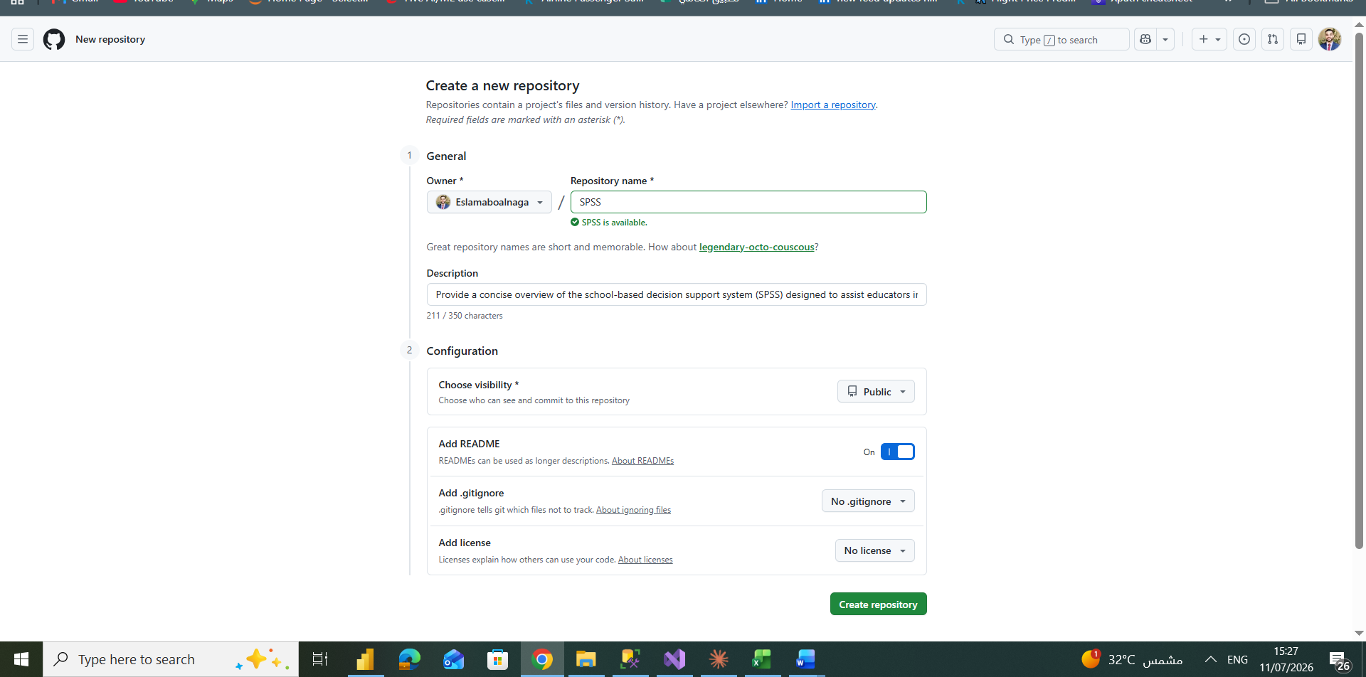
And then you must make all things like I make here and then create repository.
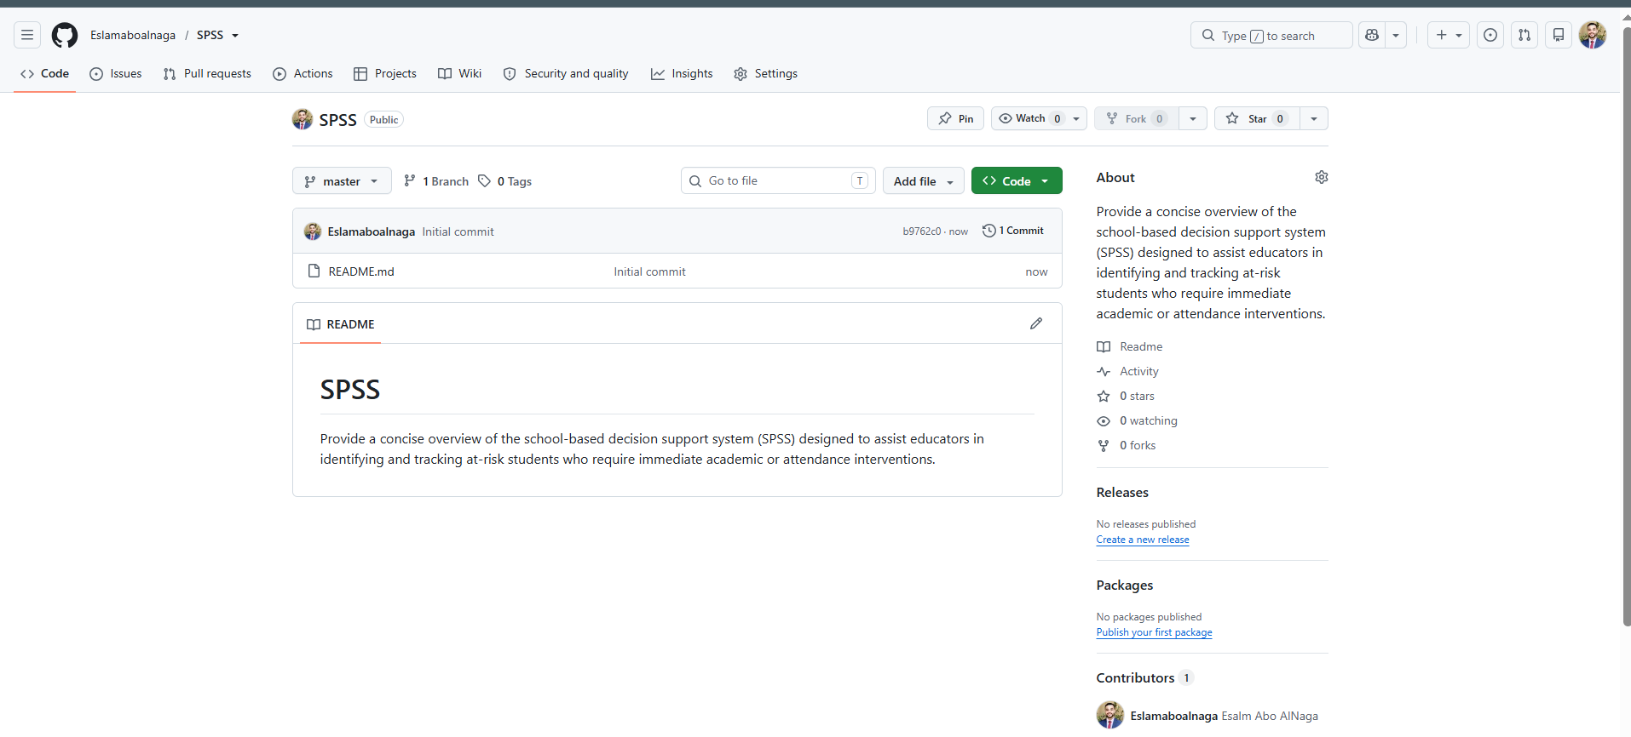
Here I make the project, now the next step for updating the repo you should add all files:
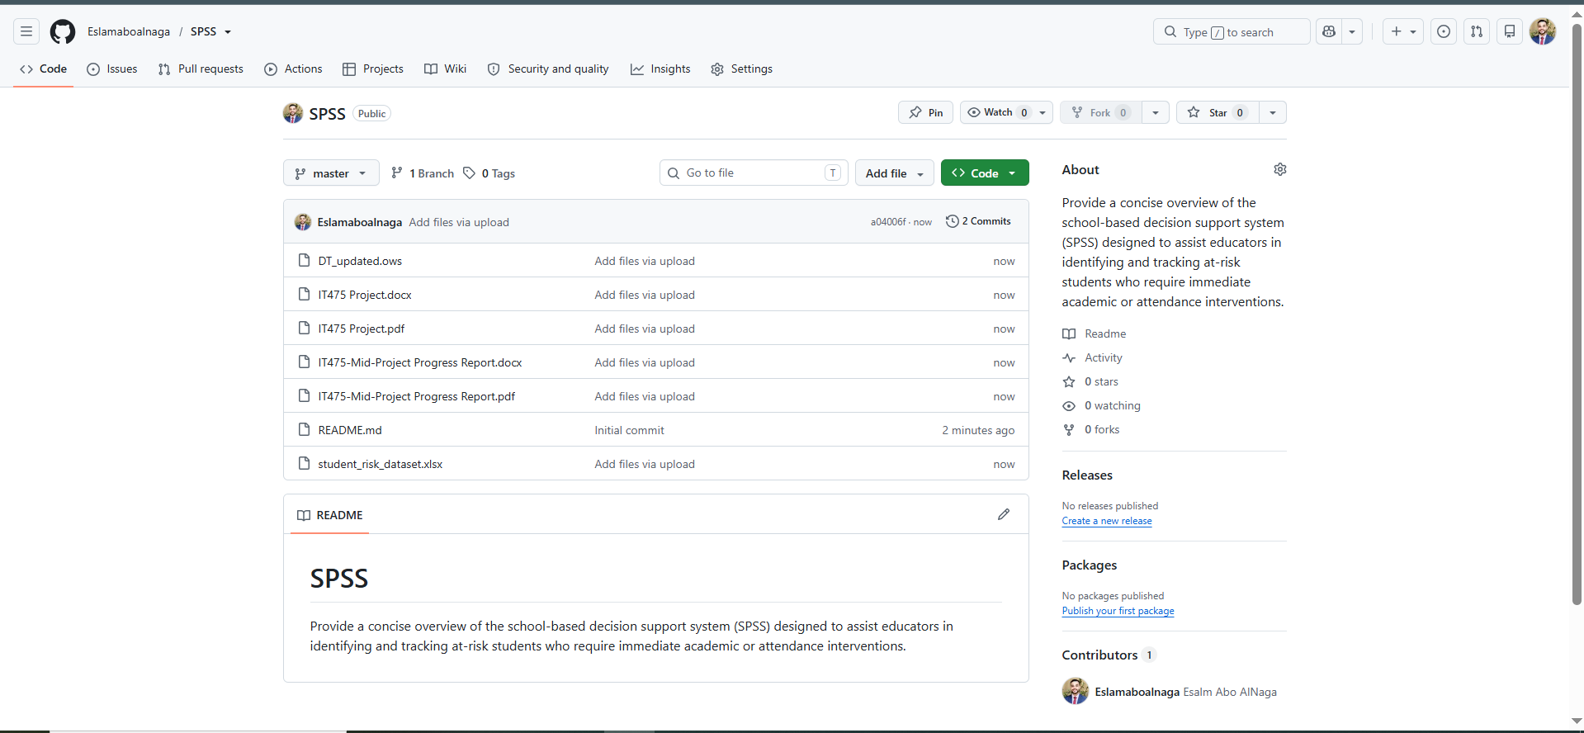

Here I upload all files as shown
And on the next step I will update the readme:
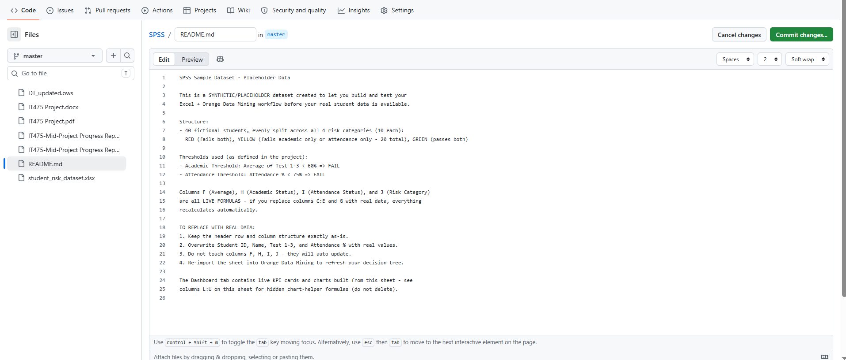

Here I update it and then I commit changes as shown:

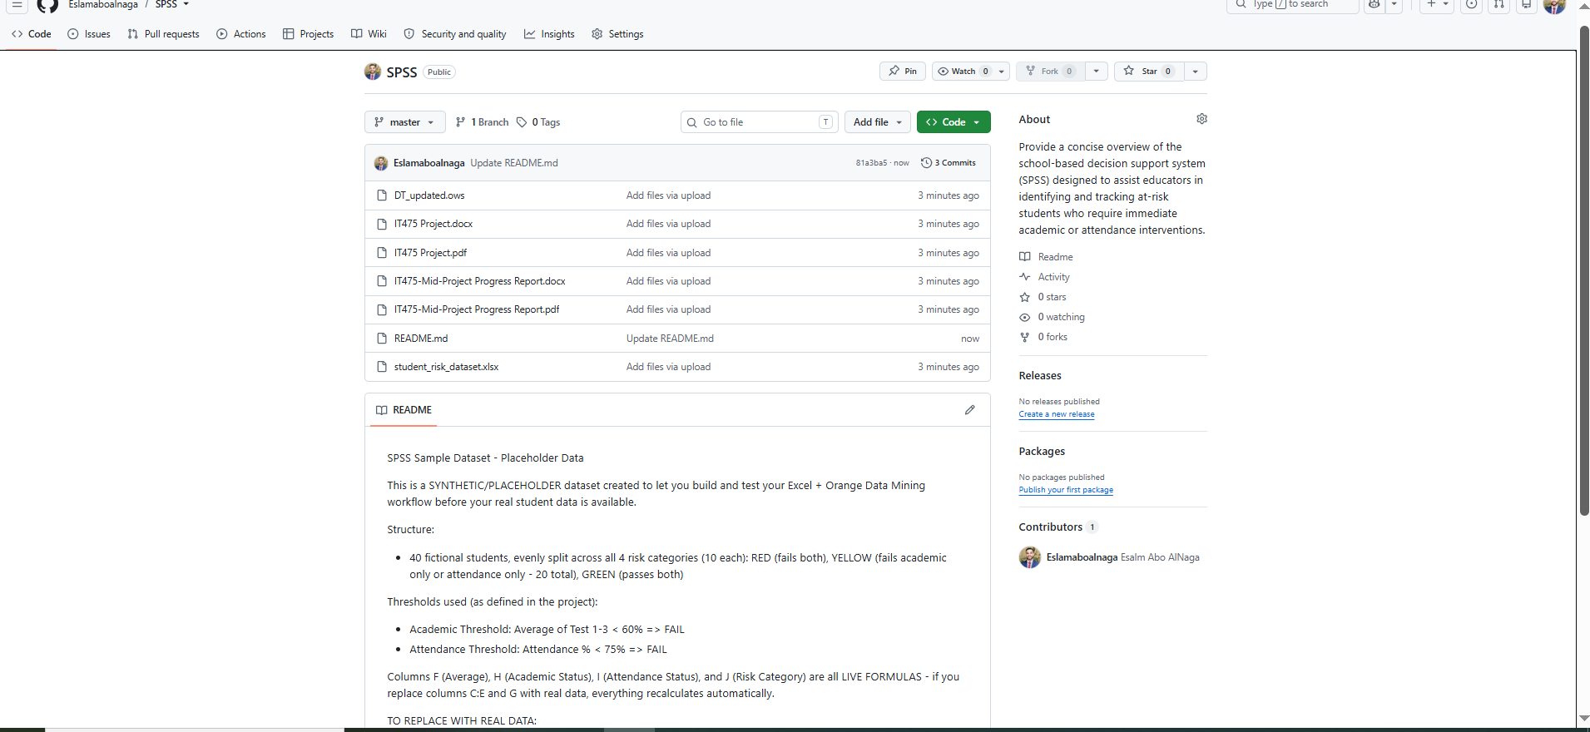

Congrats!!
The project done.

